Annex D – Data Elements Workbooks
Table of Contents:
# | Purpose | Link
1A | In accordance with the relevant registry agreements and registrar accreditation agreements, activate a registered name and allocate it to the Registered Name Holder. | LINK
1B | Subject to the Registry and Registrar Terms, Conditions and Policies and ICANN Consensus Policies:  - Establish the rights of a Registered Name Holder in a Registered Name; and  - Ensure that a Registered Name Holder may exercise its right in the use, maintenance and disposition of the Registered Name. | LINK
2 | Contributing to the maintenance of the security, stability, and resiliency of the Domain Name System in accordance with ICANN’s mission through enabling responses to lawful data disclosure requests. | LINK
3 | Enable communication with the Registered Name Holder on matters relating to the Registered Name. | LINK
4A | Provide mechanisms for safeguarding Registered Name Holders' Registration Data in the event of a business or technical failure of a Registrar or Registry Operator, or unavailability of a Registrar or Registry Operator, as described in the RAA and RA, respectively. | LINK
4B | Provide mechanisms for safeguarding Registered Name Holders' Registration Data in the event of a business or technical failure of a Registrar or Registry Operator, or unavailability of a Registrar or Registry Operator, as described in the RAA and RA, respectively. | LINK
5 | - Handle contractual compliance monitoring requests and audit activities consistent with the terms of the Registry agreement and the Registrar accreditation agreements and any applicable data processing agreements, by processing specific data only as necessary;  - Handle compliance complaints initiated by ICANN, or third parties consistent with the terms of the Registry agreement and the Registrar accreditation agreements. | LINK
6 | Operationalize policies for the resolution of disputes regarding or relating to the registration of domain names (as opposed to the use of such domain names, but including where such policies take into account use of the domain names), namely, the UDRP, URS, PDDRP, RRDRP, and the TDRP | LINK
7 | Enabling validation to confirm that Registered Name Holder meets gTLD registration policy eligibility criteria voluntarily adopted by Registry Operator and that are described or referenced in the Registry Agreement for that gTLD. | LINK

In a previous version of this document, the term “ICANN Purpose” was used in the title of the Purpose Statement for each workbook to describe purposes for processing registration data, including personal data, that should be governed by ICANN via a Consensus Policy. “ICANN” has since been removed, but the principle still applies. Note there are additional purposes for processing personal data, which the contracted parties may pursue, such as billing customers, but these are outside of what ICANN and its community should develop policy on or contractually enforce. It does not necessarily mean that such purpose is solely pursued by ICANN Org.

Primary Processing Activity Definitions:
Preamble
Definitions have been supplied with the primary types of Processing Activities of Collection, Transmission, Disclosure, and Retention. It is hoped that these definitions will provide clarity to documenting the Processing Activities and avoid confusion of their use in policy versus what may actually occur technically.

Collection
The processing action whereby the Controller or Processor gains (or gains access to) the data.

Transmission/Transfer
The processing action whereby data is disclosed by a Controller or Processor to another party when that other party is involved in the processing of those data.

Disclosure
The processing action whereby the Controller accepts responsibility for release of personal information to third parties upon request.

Publication
The processing action whereby data is disclosed to third parties, by being made publicly available for a public interest purpose.

Retention
When the primary purpose of data processing has been achieved, and/or the data is no longer required for that purpose, such data may be retained by a Controller (or Processor), where the Controller (or Processor) has established additional specific and stated purposes, and where such retention is:
- Not incompatible with the primary/original purpose for the processing of the data; or
- Reasonably necessary to demonstrate the fulfilment of the original purpose. (e.g. the retention of data to demonstrate completion, by the Controller/Processor, of a contractual obligation in contemplation of defending against claims of breach of contract etc.); and
C. Processing of retained data is limited to only those purpose(s) for which such data are retained.

Other Definitions:
- Optional: - In the Initial Report, those data elements marked as “(optional, (O))”, were used in a generic sense and ultimately caused confusion in how they traversed the processing activities.
  - Refined legend: O-RNH, O-Rr, O-CP
    - Optional for Registrant to fill in, but if supplied it must be processed
    - Optional for Registrar to provide, but if supplied it must be processed
    - Optional for contracted party subject to terms and conditions
- Generated: The data elements tables contain a list of in-scope fields of registration data as derived from existing policy, technical specifications, or contract specifications. Fields marked with an “*” are fields that are either collected from the data subject, or automatically “generated” by the registrar or registry.

Lawful Basis:
The workbooks each contain a section that documents the processing activities as well as a space to document the lawful basis. The EPDP has received legal advice regarding the application of Art. 6(1)(b), necessary for performance of a contract, as a lawful basis. To date, outside legal counsel has noted, "A registrar could rely on Article 6(1)(b) as the lawful basis for processing other than simply registering and activating a domain if it can show that such processing is for one of the fundamental objectives of the contract. It would be difficult to argue that that processing to prevent DNS abuse is "necessary for the performance of a contract to which the data subject is party". Based on this application, we have tentatively marked the processing activities of registrar collection and transfer under as lawful under 6(1)(b), while we have marked all other processing under the other purposes as 6(1)(f), noting this is a placeholder pending further legal analysis. Any designations suggested in the workbooks below is based on the EPDP Team’s best current thinking but that in the end the determination is a result of law not opinion.

Data Flow Diagrams and Data Elements Tables:
- The diagrams are simple representations arrangements (colored data flow lines) between ICANN, Contracted Parties, Service Providers, and the Data Subject (Registrant). They are not an accurate depiction of the exact agreements that may already exist or future ones. Further, the data flows (black lined data flow) are also not representative of what how the data may actually flow technically. More detailed analysis and documentation will be required to accurately reflect the data flow.
- The data elements tables are also limited in how they properly reflect how data traverses the processing activities identified for each purpose. They act more as a policy tool to manage an inventory of data elements used in existing publicly accessible Whois directory today. Further, the roles played are also more complex than what is represented here. For example, the processing activity of a transfer means that one party performs the “transfer”, while the receiving party is “collecting” the data.

1A | PURPOSE:  In accordance with the relevant Registry Agreements and Registrar Accreditation Agreements, activate a registered name and allocate it to the Registered Name Holder.
Purpose Rationale:
1) If the purpose is based on an ICANN contract, cite the relevant section of the ICANN contracts that corresponds to the above purpose, if any.

- RAA - https://www.icann.org/resources/pages/approved-with-specs-2013-09-17-en

Yes, this purpose is lawful based on ICANN’s mission to coordinate the allocation and assignment of names in the root zone of the Domain Name System. Specifically, Section 3.2 of the RAA “Submission of Registered Name Holder Data to Registry” refers to what data elements must be placed in the Registry Database as a part of the domain registration (https://www.icann.org/resources/pages/approved-with-specs-2013-09-17-en) & https://www.icann.org/resources/pages/registries/registries-agreements-en).

2) Is the purpose in violation with ICANN's bylaws?

No, it is not in violation of ICANN’s Bylaws. Specifically, Article 1, Section 1.1 Mission (a)(i) Coordinates the allocation and assignment of names in the root zone of the Domain Name System ("DNS") and coordinates the development and implementation of policies concerning the registration of second-level domain names in generic top-level domains ("gTLDs"). In this role, ICANN's scope is to coordinate the development and implementation of policies https://www.icann.org/resources/pages/governance/bylaws-en/#article1.

Further, Articles G-1 and G-2 stipulate, “issues for which uniform or coordinated resolution is reasonably necessary to facilitate interoperability, security and/or stability of the Internet, registrar services, registry services, or the DNS;” and “Examples of the above include, without limitation: principles for allocation of registered names in a TLD (e.g., first-come/first-served, timely renewal, holding period after expiration);”

3) Are there any “picket fence” considerations related to this purpose?

This purpose is related to WHOIS, which is within the Picket Fence. Specifically, Specification 1 of the Registry Agreement (Section 3.1(b) (iv) and (v) of legacy RA) and Specification 4 of the Registrar Accreditation Agreement both refer to categories of issues and principles of allocation of registered names in a TLD.

Lawfulness of Processing Test:
Processing Activity: | Responsible Party:  (Charter Questions 3k, 3l, 3m) | Lawful Basis: (Is the processing necessary to achieve the purpose?)
1A-PA1: Collection of registration data to allocate and activate the domain name string to Registered Name Holder  (Charter Question 2b) | ICANN  Registrars  Registries  RNH | 6(1)(b) for Registrars  This is a 6(1)(b) purpose for Registrars because it is necessary to collect registrant data to allocate a string to a registrant. Without collecting minimal registrant data, the contracted party has no way of tracing the string back to registrant and is not able to deliver its side of the contract.  6(1)(f) for Registries and ICANN  This is a 6(1)(f) purpose for Registries receiving such data from Registrars to allocate the domain name at the Registry level, this collection is based on 6(1)(f) purpose.  (NOTE: that registries collection of the data occurs only when the data is disclosed to them by the registrar as per 1A-PA2)
1A-PA2: Transmission of registration data from Registrar to Registry  (Charter Questions 2c, 2d, 2e, 2i) | ICANN  Registrars  Registries | Certain data elements (Domain Name and NameServers) would be required to be transferred from the Registrar to Registry. The lawful basis would be 6(1)(b) (vis á vis the processing of the Registrar), should personal data be involved.  (NOTE: the Registry’s receipt of this data is the collection, as per 1A-PA1)
1A-PA3: Publication of registration data to the DNS  (Charter Questions 2f (gating questions), 2j) | ICANN  Registrars  Registries | Activation of the domain name registration in the DNS requires the publication of certain data elements, namely Domain Name and NameServers. The lawful basis would be 6(1)(f), should personal data be involved.  Due to the minimal discretion in the requirements of 1A this is a direction from ICANN on what and how to achieve the result. Registries and Registrars retain minimal discretion and thus are acting as processors in 1A.
1A-PA4: Retention of registration data by Registrar, Registry  (Charter Questions 2g)  Note, this PA is not represented on the data elements table, because data processed above represents what data elements will be retained | ICANN  Registrars  Registries | 6(1)(f) for Registrars  This is a 6(1)(f) purpose because although there is likely a legitimate interest in providing mechanisms for safeguarding Registered Name Holders' Registration Data in the event of a dispute over ownership or an improper transfer, it is not necessary from a technical perspective to retain the data in order to allocate a string to a registered name holder, and therefore is not necessary to perform the registration contract.  The EPDP Team agreed to a period of one year following the life of the registration a registration as the retention period in order to conform with the Transfer Dispute Resolution Policy requirements. Refer to the details around retention in Recommendation #11  6(1)(f) for Registries  Registries need only retain data for the duration of the life of the domain.

Data Flow Map:
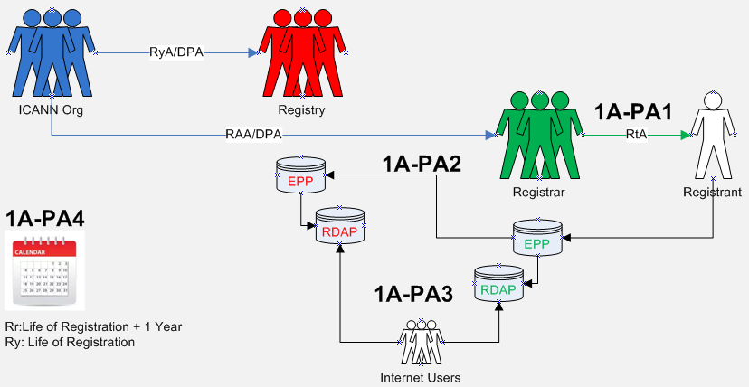

PURPOSE:
In accordance with the relevant Registry Agreements and Registrar Accreditation Agreements, activate a registered name and allocate it to the Registered Name Holder.

Data Elements Matrix:
R = required
O-RNH, O-Rr, O-CP = optional
N/A=not applicable

Data Elements  (Collected & Generated*) | Collection  1A-PA1 | Transmission  1A-PA2 | Publication  1A-PA3
Domain Name | R | R | R
Registry Domain ID*
Registrar Whois Server*
Registrar URL*
Updated Date*
Creation Date*
Registry Expiry Date*
Registrar Registration Expiration Date*
Registrar*
Registrar IANA ID*
Registrar Abuse Contact Email*
Registrar Abuse Contact Phone*
Reseller*
Domain Status(es)*
Registry Registrant ID*
Registrant Fields
• Name
• Organization (opt.)
• Street
• City
• State/province
• Postal code
• Country
• Phone
• Phone ext (opt.)
• Fax (opt.)
• Fax ext (opt.)
• Email
2nd E-Mail address
Admin ID*
Admin Fields
• Name
• Organization (opt.)
• Street
• City
• State/province
• Postal code
• Country
• Phone
• Phone ext (opt.)
• Fax (opt.)
• Fax ext (opt.)
• Email
Tech ID*
Tech Fields
• Name
• Organization (opt.)
• Street
• City
• State/province
• Postal code
• Country
• Phone
• Phone ext (opt.)
• Fax (opt.)
• Fax ext (opt.)
• Email
NameServer(s) | O-RNH | O-RNH | O-RNH
DNSSEC | O-RNH | O-RNH | O-RNH
Name Server IP Address | O-RNH | O-RNH | O-RNH
Last Update of Whois Database*

1B | PURPOSE:  As subject to registry and registrar terms, conditions and policies, and ICANN consensus policies:  (i) establish the rights of a Registered Name Holder in a registered name, and  (ii) ensure that a Registered Name Holder may exercise its rights in the use, maintenance and disposition of the Registered Name.
Purpose Rationale:
1) If the purpose is based on an ICANN contract, cite the relevant section of the ICANN contracts that corresponds to the above purpose, if any.

- RAA - https://www.icann.org/resources/pages/approved-with-specs-2013-09-17-en

Yes, this purpose is lawful based on ICANN’s mission to coordinate the allocation and assignment of names in the root zone of the Domain Name System. Specifically, Section 3.2 of the RAA “Submission of Registered Name Holder Data to Registry” , Spec. 4, section 1.5 and Spec. 2 of the RA, all refers to what data elements must be placed in the Registry Database as a part of the domain registration (https://www.icann.org/resources/pages/approved-with-specs-2013-09-17-en & https://www.icann.org/resources/pages/registries/registries-agreements-en).

2) Is the purpose in violation with ICANN's bylaws?

No, it is not in violation of ICANN’s Bylaws. Specifically, Article 1, Section 1.1 Mission (a)(i) Coordinates the allocation and assignment of names in the root zone of the Domain Name System ("DNS") and coordinates the development and implementation of policies concerning the registration of second-level domain names in generic top-level domains ("gTLDs"). In this role, ICANN's scope is to coordinate the development and implementation of policies https://www.icann.org/resources/pages/governance/bylaws-en/#article1.

Further, Articles G-1 and G-2 stipulate, “issues for which uniform or coordinated resolution is reasonably necessary to facilitate interoperability, security and/or stability of the Internet, registrar services, registry services, or the DNS;” and “Examples of the above include, without limitation: principles for allocation of registered names in a TLD (e.g., first-come/first-served, timely renewal, holding period after expiration);”

3) Are there any “picket fence” considerations related to this purpose?

This purpose is related to WHOIS, which is within the Picket Fence. Specifically, Specification 1 of the Registry Agreement (Section 3.1(b)(iv) and (v) and Specification 4 of the Registrar Accreditation Agreement both refer to categories of issues and principles of allocation of registered names in a TLD.

Lawfulness of Processing Test:
Processing Activity: | Responsible Party:  (Charter Questions 3k, 3l, 3m) | Lawful Basis: (Is the processing necessary to achieve the purpose?)
1B-PA1: Collection of registration data to establish registrant’s rights in a domain name string  (Charter Question 2b) | ICANN  Registrars  Registries | 6(1)(b) for Registrars  This is a 6(1)(b) purpose for Registrars because it is necessary to collect registrant data to allocate a string to a registrant. Without collecting minimal registrant data, the contracted party has no way of tracing the string back to registrant and is not able to deliver its side of the contract.  6(1)(f) for Registries and ICANN  This is a 6(1)(f) purpose for Registries that require the collection of data to fulfill their terms, conditions and policies, this is a 6(1)(f) purpose.  (NOTE: that registries collection of the data occurs only when the data is disclosed to them by the registrar as per 1B-PA2)
1B-PA2: Transmission of registration data from Registrar to Registry  (Charter Questions 2c, 2d, 2e, 2i) | ICANN  Registrars  Registries | Registries may direct a Registrar to provide a limited data set, (i.e. data set that differs from the from the Minimum Data Set as required as per the relevant consensus policy), where such a Registry Operator , due to varying business model and legal interpretations of obligations, require an alternate data set to fulfill, in their subjective evaluation, their specific policies, terms and conditions (for example, for the purpose of administering the application of a Registry Acceptable Use Policy (AUP)) in cases where such policies exist.  The disclosure of the data by the registrar to the registry is justified under 6(1)(b) (vis á vis the registrar’s processing) for the valid purpose of enabling the registry to then, where necessary, directly enforce the registration terms or acceptable use policy of the registry, where such a registry chooses to do so.  Note: Joint controllership results in a required element of the RA (Spec 11) vs. the interpretation of the Registry, where in some instances this is not considered to be required as this is a RA pass on. It is also accepted that some registry operators have the ability to ‘choose’ how to interpret their obligations under Spec 11, and therefore this additional exercising of control would tend to suggest that registries retain a relationship closer to a Joint Controller in the realization of purpose 1B.  (NOTE: the Registry’s receipt of this data is the collection, as per 1B-PA1)
1B-PA3: Disclosure of registration data for lawful purposes  (Charter Questions 2f (gating questions), 2j) | ICANN  Registrars  Registries | Establishing the rights of a RNH, and ensuring, subject to Terms & Conditions, that a RNH may exercise such benefits, may require disclosure of certain data elements, namely registrant details, IP addresses, domain names and name servers. The lawful basis would be 6(1)(f), should personal data be involved.
1B-PA4: Retention of registration data by Registrar, Registry  (Charter Questions 2g)  Note, this PA is not represented on the data elements table, because data processed above represents what data elements will be retained | ICANN  Registrars  Registries | This is a 6(1)(f) purpose because although there is likely a legitimate interest in providing mechanisms for safeguarding Registered Name Holders' Registration Data in the event of a dispute over ownership or an improper transfer, it is likely necessary for the registrar to retain the data to enforce their terms and conditions, however after the expiration of a domain, this retention is as per the register’s own controllership.  ------  6(1)(f) for Registrars  This is a 6(1)(f) purpose because although there is likely a legitimate interest in providing mechanisms for safeguarding Registered Name Holders' Registration Data in the event of a dispute over ownership or an improper transfer, it is not necessary from a technical perspective to retain the data in order to allocate a string to a registered name holder, and therefore is not necessary to perform the registration contract.  The EPDP Team agreed to a period of one year following the life of the registration a registration as the retention period in order to conform with the Transfer Dispute Resolution Policy requirements. Refer to the details around retention in Recommendation #11  6(1)(f) for Registries  Registries need only retain data for the duration of the life of the domain.

Data Flow Map:
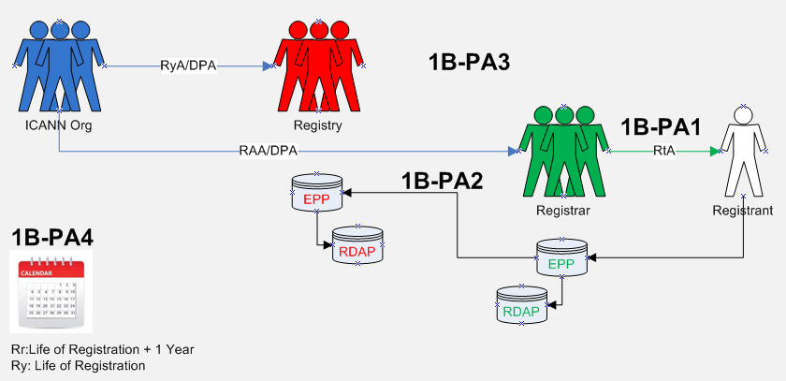

PURPOSE:
As subject to registry and registrar terms, conditions and policies, and ICANN consensus policies:
(i) establish the rights of a Registered Name Holder in a registered name, and
(ii) ensure that a Registered Name Holder may exercise its rights in the use, maintenance and disposition of the registered name.

Data Elements Matrix:
R = required
O-RNH, O-Rr, O-CP = optional
N/A=not applicable

Data Elements  (Collected & Generated*) | Collection  1B-PA1 | Transmission  1B-PA2 | Disclosure  1B-PA3
Domain Name | R | R | R
Registry Domain ID*
Registrar Whois Server* | R | O-CP | O-CP
Registrar URL* | R | O-CP | O-CP
Updated Date* | R | O-CP | O-CP
Creation Date*
Registry Expiry Date*
Registrar Registration Expiration Date* | O-Rr | O-CP | O-CP
Registrar* | R | R | R
Registrar IANA ID* | R | R | R
Registrar Abuse Contact Email* | R | O-CP | O-CP
Registrar Abuse Contact Phone* | R | O-CP | O-CP
Reseller* | O-Rr | O-CP | O-CP
Domain Status(es)* | R | O-CP | O-CP
Registry Registrant ID*
Registrant Fields
• Name | R | O-CP | O-CP
• Organization (opt.) | O-RNH | O-CP | O-CP
• Street | R | O-CP | O-CP
• City | R | O-CP | O-CP
• State/province | R | O-CP | O-CP
• Postal code | R | O-CP | O-CP
• Country | R | O-CP | O-CP
• Phone | R | O-CP | O-CP
• Phone ext (opt.)
• Fax (opt.)
• Fax ext (opt.)
• Email | R | O-CP | O-CP
2nd E-Mail address
Admin ID*
Admin Fields
• Name
• Organization (opt.)
• Street
• City
• State/province
• Postal code
• Country
• Phone
• Phone ext (opt.)
• Fax (opt.)
• Fax ext (opt.)
• Email
Tech ID*
Tech Fields
• Name
• Organization (opt.)
• Street
• City
• State/province
• Postal code
• Country
• Phone
• Phone ext (opt.)
• Fax (opt.)
• Fax ext (opt.)
• Email
NameServer(s)
DNSSEC
Name Server IP Address
Last Update of Whois Database*

2 | PURPOSE:  Contributing to the maintenance of the security, stability, and resiliency of the Domain Name System in accordance with ICANN’s mission through enabling responses to lawful data disclosure requests.
Purpose Rationale:
1) If the purpose is based on an ICANN contract, cite the relevant section of the ICANN contracts that corresponds to the above purpose, if any.

- RAA - https://www.icann.org/resources/pages/approved-with-specs-2013-09-17-en

Yes, this purpose is lawful based on ICANN’s mission to coordinate the allocation and assignment of names in the root zone of the Domain Name System. Specifically, ICANN contracts reference the requirement for the maintenance of and access to accurate and up-to-date information concerning domain name registrations.

2) Is the purpose in violation with ICANN's bylaws?

No, it is not in violation of ICANN’s Bylaws, see ICANN Bylaws - Section 1.1(d)(ii), Section 1.2(a), Section 4.6(e)(i), Annex G1 and G2.

3) Are there any “picket fence” considerations related to this purpose?

This is within the Picket Fence, as the purpose specially refers to data already collected.

The WHOIS system, including 3rd party access, is within the Picket Fence, note specifically the Consensus Policies and Temporary Policies specification in the Registrar Accreditation Agreement (RAA) 1.3.4. maintenance of and access to accurate and up-to-date information concerning Registered Names and name servers; Registry Agreement (RA) - maintenance of and access to accurate and up-to-date information concerning domain name registrations.

Lawfulness of Processing Test:
Processing Activity: | Responsible Party::  (Charter Questions 3k, 3l, 3m) | Lawful Basis: (Is the processing necessary to achieve the purpose?)
2-PA1: Collection of registration data by Registrar  (Charter Question 2b) | ICANN  Registrars  Registries | The lawful basis for this processing activity is Art.6(1)(f) of the GDPR because although there may be a legitimate interest in disclosing non-public RDDS/WHOIS to third parties (such as law enforcement, IP interests, etc.), this disclosure is not technically necessary to perform the registration contract between the registrant and registrar.  (NOTE: that registries collection of the data occurs only when the data is disclosed to them by the registrar as per 2-PA2)
2-PA2: Transmission of registration data from Registrar to Registry  (Charter Questions 2c, 2d, 2e, 2i) | ICANN  Registrars  Registries | This would be a 6(1)(f) processing activity because while there may be a legitimate interest in third parties contacting the registrant (for example, to inform the registrant or designee of a technical issue with the domain name), this is not necessary for the performance of the contract from a registry perspective.  (NOTE: the Registry’s receipt of this data is the collection, as per 2-PA1)
2-PA3: Disclosure of non-public, already collected, registration data to third parties  (Charter Questions 2f (gating questions), 2j) | ICANN  Registrars  Registries  Third Parties | This is a 6(1)(f) processing activity because although there may be a legitimate interest in disclosing non-public RDDS/WHOIS to third parties (such as law enforcement, IP interests, etc.), this disclosure is not technically necessary to perform the registration contract between the registrant and registrar.  (Note: the requisite balancing test must be performed for each third-party type of disclosure and not for all registration data all the time.)
2-PA4: Retention of registration data by registrar  Note, this PA is not represented on the data elements table, because data processed above represents what data elements will be retained  (Charter Questions 2g) | ICANN  Registrars  Registries | This processing activity is not required for the Purpose of providing lawful disclosures and further relies on retention as documented in Purpose 1A & 1B.

Data Flow Map:
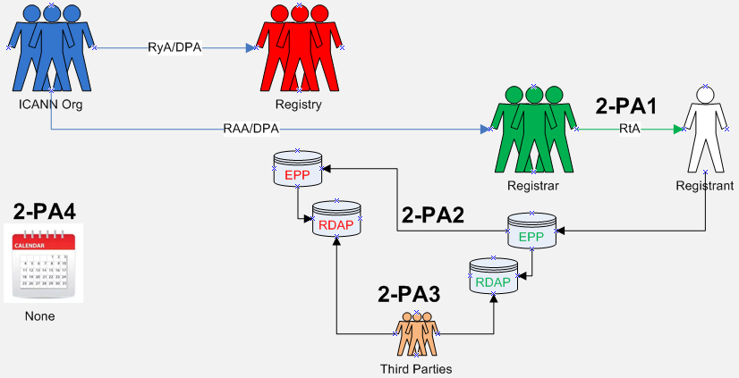

PURPOSE:
Contributing to the maintenance of the security, stability, and resiliency of the Domain Name System in accordance with ICANN’s mission through enabling responses to lawful data disclosure requests.

Data Elements Matrix:
R = required
O-RNH, O-Rr, O-CP = optional
N/A=not applicable

Data Element  (Collected & Generated*) |  |  | Disclosure  2-PA3
Domain Name |  |  | R
Registry Domain ID* |  |  | R
Registrar Whois Server* |  |  | R
Registrar URL* |  |  | R
Updated Date* |  |  | R
Creation Date* |  |  | R
Registry Expiry Date* |  |  | R
Registrar Registration Expiration Date* |  |  | R
Registrar* |  |  | R
Registrar IANA ID* |  |  | R
Registrar Abuse Contact Email* |  |  | R
Registrar Abuse Contact Phone* |  |  | R
Reseller* |  |  | R
Domain Status(es)* |  |  | R
Registry Registrant ID* |  |  | R
Registrant Fields
• Name |  |  | R
• Organization (opt.) |  |  | R
• Street |  |  | R
• City |  |  | R
• State/province |  |  | R
• Postal code |  |  | R
• Country |  |  | R
• Phone |  |  | R
• Phone ext (opt.)
• Fax (opt.)
• Fax ext (opt.)
• Email |  |  | R
2nd E-Mail address
Admin ID*
Admin Fields
• Name
• Organization (opt.)
• Street
• City
• State/province
• Postal code
• Country
• Phone
• Phone ext (opt.)
• Fax (opt.)
• Fax ext (opt.)
• Email
Tech ID* |  |  | R
Tech Fields
• Name |  |  | R
• Organization (opt.)
• Street
• City
• State/province
• Postal code
• Country
• Phone |  |  | R
• Phone ext (opt.)
• Fax (opt.)
• Fax ext (opt.)
• Email |  |  | R
NameServer(s) |  |  | R
DNSSEC |  |  | R
Name Server IP Address |  |  | R
Last Update of Whois Database* |  |  | R

3 | PURPOSE:  Enable communication with the Registered Name Holder on matters relating to the Registered Name.
Purpose Rationale:
1) If the purpose is based on an ICANN contract, cite the relevant section of the ICANN contracts that corresponds to the above purpose, if any.

Yes, this purpose is lawful based on ICANN’s mission to coordinate the allocation and assignment of names in the root zone of the Domain Name System. Specifically, section 3.7.7.3 of the RAA refers to providing and updating contact information to facilitate timely resolution of any problems that arise in connection with the Registered Name.

2) Is the purpose in violation with ICANN's bylaws?

No, it is not in violation of ICANN’s Bylaws. Specifically, Article 1, Section 1.1 Mission (a)(i) Coordinates the allocation and assignment of names in the root zone of the Domain Name System ("DNS") and coordinates the development and implementation of policies concerning the registration of second-level domain names in generic top-level domains ("gTLDs"). In this role, ICANN's scope is to coordinate the development and implementation of policies https://www.icann.org/resources/pages/governance/bylaws-en/#article1.

Further, Articles G-1 and G-2 stipulate, “issues for which uniform or coordinated resolution is reasonably necessary to facilitate interoperability, security and/or stability of the Internet, registrar services, registry services, or the DNS;” and “Examples of the above include, without limitation: principles for allocation of registered names in a TLD (e.g., first-come/first-served, timely renewal, holding period after expiration);”.

3) Are there any “picket fence” considerations related to this purpose?

This purpose is related to WHOIS, which is within the Picket Fence. Specifically, Specification 1 of the Registry Agreement and Specification 4 of the Registrar Accreditation Agreement both refer to categories of issues and principles of allocation of registered names in a TLD.

Lawfulness of Processing Test:
Processing Activity: | Responsible Party:  (Charter Questions 3k, 3l, 3m) | Lawful Basis: (Is the processing necessary to achieve the purpose?)
3-PA1: Collection of registration data by Registrars  (Charter Question 2b) | ICANN  Registrars  Registries | For Registrars  6(1)(b) - For registrars: This is a 6(1)(b) purpose because it is necessary to collect registrant data so that the registrar can contact the registrant in the event a communication is necessary to maintain the domain operation.  For Registries  6(1)(f) - For third parties who would like to report technical issues to a technical contact: This would be a 6(1)(f) purpose because while there may be a legitimate interest in third parties contacting the registrant (for example, to inform the registrant or designee of a technical issue with the domain name), this is not necessary for the performance of the contract.
3-PA2: Transmission of registration data from Registrar to Registry  (Charter Questions 2c, 2d, 2e, 2i) | N/A | This processing activity is not applicable. The transfer of data from the Registrar to the Registry is not necessary to still enable Registry communication with the Registered Name Holder.  Note that while a “transfer” of registration data as documented here is not required, the Registry will have still received non-public data as part of the registration process in EPP.
3-PA3: Disclosure of registration data to enable communication with RNH  (Charter Questions 2f (gating questions), 2j) | ICANN  Registrars  Registries  RNH | In compliance with GDPR, non-public information must not be improperly disclosed and when it is, it is only for a lawful and specific purpose.  Occurs, for example, when responding to court orders.
3-PA4: Publication of public, already collected, registration data to Internet Users  (Charter Questions 2f (gating questions), 2j) | ICANN  Registrars  Registries  Internet Users | A minimum public data set of registration data will be made available for query of gTLD second level domains in a freely accessible directory. Where a data element has been designated as non-public, it will be redacted, see 3-PA6.
3-PA5: Redaction of registration data to Internet Users | ICANN  Registrars  Registries  Internet Users | In compliance with GDPR, non-public information must not be improperly disclosed and when it is, it is only for a lawful and specific purpose.
3-PA6: Retention of registration data  Note, this PA is not represented on the data elements table, because data processed above represents what data elements will be retained  (Charter Questions 2g) | ICANN  Registrars  Registries | N/A – A retention period of registration data is not required to meet the intent of this purpose.

Data Flow Map:
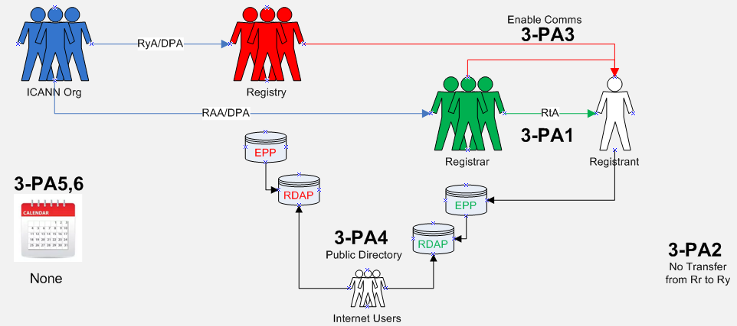
PURPOSE:
Enable communication with the Registered Name Holder on matters relating to the Registered Name.

Data Elements Matrix:
R = required
O-RNH, O-Rr, O-CP = optional
N/A=not applicable

Data Element  (Collected & Generated*) | Collection  3-PA1 | Transmission  3-PA2 | Publication (registry)  3-PA4 | Publication (registrar)  3-PA4 | Redaction  3-PA5
Domain Name | R | R | R | R | No
Registry Domain ID* |  | R | R | R | Yes
Registrar Whois Server* | R | R | R | R | No
Registrar URL* | R | R | R | R | No
Updated Date* | R | R | R | R | No
Creation Date* |  | R | R | R | No
Registry Expiry Date* |  | R | R | R | No
Registrar Registration Expiration Date* | O-Rr | O-CP | O-CP | O-CP | No
Registrar* | R | R | R | R | No
Registrar IANA ID* | R | R | R | R | No
Registrar Abuse Contact Email* | R | R | R | R | No
Registrar Abuse Contact Phone* | R | R | R | R | No
Reseller* | O-Rr | O-CP | O-CP | O-CP | No
Domain Status(es)* | R | R | R | R | No
Registry Registrant ID* |  | R | R | R | Yes
Registrant Fields
• Name | R | O-CP | O-CP | R | Yes
• Organization (opt.) | O-RNH | O-CP | O-CP | O-RNH | Yes
• Street | R | O-CP | O-CP | R | Yes
• City | R | O-CP | O-CP | R | Yes
• State/province | R | O-CP | O-CP | R | No
• Postal code | R | O-CP | O-CP | R | Yes
• Country | R | O-CP | O-CP | R | No
• Phone | R | O-CP | O-CP | R | Yes
• Phone ext (opt.)
• Fax (opt.)
• Fax ext (opt.)
• Email | R | O-CP | O-CP | R | Yes
2nd E-Mail address
Admin ID*
Admin Fields
• Name
• Organization (opt.)
• Street
• City
• State/province
• Postal code
• Country
• Phone
• Phone ext (opt.)
• Fax (opt.)
• Fax ext (opt.)
• Email
Tech ID* |  | O-CP | O-CP | R | Yes
Tech Fields
• Name | O-RNH | O-CP | O-CP | R | Yes
• Organization (opt.)
• Street
• City
• State/province
• Postal code
• Country
• Phone | O-RNH | O-CP | O-CP | R | Yes
• Phone ext (opt.)
• Fax (opt.)
• Fax ext (opt.)
• Email | O-RNH | O-CP | O-CP | R | Yes
NameServer(s) | O-RNH | O-RNH | O-RNH | O-RNH | No
DNSSEC | O-RNH | O-RNH | O-RNH | O-RNH | No
Name Server IP Address | O-RNH | O-RNH | O-RNH | O-RNH | No
Last Update of Whois Database* | R | R | R | R | No

4A | PURPOSE:  --For Registrars Only--  Provide mechanisms for safeguarding Registered Name Holders’ Registration Data in the event of a business or technical failure of a Registrar or Registry Operator, or unavailability of a Registrar or Registry Operator, as described in the RAA and RA, respectively.
Purpose Rationale:
1) If the purpose is based on an ICANN contract, cite the relevant section of the ICANN contracts that corresponds to the above purpose, if any.

- Registrar Data Escrow Program: https://www.icann.org/resources/pages/registrar-data-escrow-2015-12-01-en
- Data Fields Source: https://www.icann.org/en/system/files/files/rde-specs-09nov07-en.pdf

Escrowing the data is supported by ICANN’s mandate to provide for security and stability in the DNS and this purpose is primarily protecting the registrant’s rights. Escrow exists because Registrants have a reasonable expectation of business continuity.

It is reasonable to expect that a DPA would consider the escrow of customer data critical to the delivery of the service being provided to be common business practice and legal under GDPR provided appropriate contractual relationships are in place with the escrow agent to ensure that the data, once transferred to the escrow agent is afforded appropriate protection.

While technical and business resiliency could be achieved via other mechanisms, the escrow of data necessary to deliver the service is a generally accepted practice that is likely to be considered necessary to achieve the purpose of “…safeguarding registered name holder’s registration data in the event of a business or technical failure, or other unavailability…”

While all contracted parties that have to be compliant with GDPR need to make sure there are protections against data loss and mechanisms to enable swift data recovery, ICANN is operating at the global level where customers can register domain names with registrars globally and the registry operators are based in numerous jurisdictions, it is important to have interoperability of escrow agents. Requiring all contracted parties to use the same policies for both escrowing data and applying the same standards to escrow agents for making data available, is necessary for contingency planning at the global level.

2) Is the purpose in violation with ICANN's bylaws?

No, providing a safety net for registrants in the event of registry technical of business failure seems within ICANN’s remit.

1.1(a)(i) Coordinates the allocation and assignment of names in the root zone of the Domain Name System ("DNS") and coordinates the development and implementation of policies concerning the registration of second-level domain names in generic top-level domains ("gTLDs"). In this role, ICANN's scope is to coordinate the development and implementation of policies:
- For which uniform or coordinated resolution is reasonably necessary to facilitate the openness, interoperability, resilience, security and/or stability of the DNS including, with respect to gTLD registrars and registries, policies in the areas described in Annex G-1 and Annex G-2; and
- That are developed through a bottom-up consensus-based multistakeholder process and designed to ensure the stable and secure operation of the Internet's unique names systems.
The issues, policies, procedures, and principles addressed in Annex G-1 and Annex G-2 with respect to gTLD registrars and registries shall be deemed to be within ICANN's Mission.

3) Are there any “picket fence” considerations related to this purpose?

Only with respect to the data model(s) defined within RDDS/Whois consensus policies. Agreements between ICANN and escrow providers are not within scope of the picket fence.

Lawfulness of Processing Test:
Processing Activity: | Responsible Party:  (Charter Questions 3k, 3l, 3m) | Lawful Basis: (Is the processing necessary to achieve the purpose?)
4A-PA1: Collection of registration data by Registrar  (Charter Question 2b) | ICANN  Registrars | 6(1)(f)  This Processing Activity of Collection is not required to be documented within the Purpose for Registrar Escrow because the processing activity for transmission of registration data to the Data Escrow Agent (as noted below) has already been collected or generated from other ICANN Purposes that also contain processing activities for the collection of registration data.  However, the transparency of collection to the Registrant/Data Subject for the purpose of escrow is required. Refer to the Purpose for establishing the rights of the Registered Name Holder.
4A-PA2: Transmission of registration data to Data Escrow Agent  (Charter Questions 2c, 2d, 2e, 2i) | ICANN  Registrars  Data Escrow Agent | This is a 6(1)(f) lawful basis because although there is likely a legitimate interest in providing mechanisms for safeguarding Registered Name Holders' Registration Data in the event of a business or technical failure, or other unavailability of a Registrar or Registry Operator, it is not technically necessary to transmit data to an escrow agent in order to allocate a string to a registered name holder, and is therefore not necessary to perform the registration contract.
4A-PA3: Disclosure of registration data to Gaining Registrar  (Charter Questions 2f (gating questions), 2j) | ICANN  Data Escrow Agent  Gaining Registrar | This is a 6(1)(f) lawful basis because although there is likely a legitimate interest in providing mechanisms for safeguarding Registered Name Holders' Registration Data in the event of a business or technical failure, or other unavailability of a Registrar or Registry Operator, it is not technically necessary to transmit data to an escrow agent in order to allocate a string to a registered name holder, and is therefore not necessary to perform the registration contract.  Data is not made public for escrow purposes, but a transfer to the escrow agent and - in case of contingencies - the transfer to a Gaining Registrar is required to ensure that operations are not impaired.  How and who ICANN choses as the Gaining Registrar may have additional implications to the lawfulness should the Gaining Registrar not reside within the EU when the Losing Registrar did reside within the EU.
4A-PA4: Retention of registration data by Data Escrow Agent  Note, this PA is not represented on the data elements table, because data processed above represents what data elements will be retained  (Charter Questions 2g) | ICANN  Data Escrow Agent | This is a 6(1)(f) lawful basis due to the connection of Retention with Transmission of registration data to the Data Escrow Agent from the Registry.  From the Escrow Specification (3.3.1.6), deposits to Third-Party Escrow Agents two copies are held for one year.  Questions about the validity of the one year for TPP, noting that no retention is listed for ICANN approved vendors, given that once a new deposit occurs and is verified, it renders prior deposits useless.  The EPDP also discussed that perhaps some minimal retention could be necessary from an overall continuity perspective.

Data Flow Map:
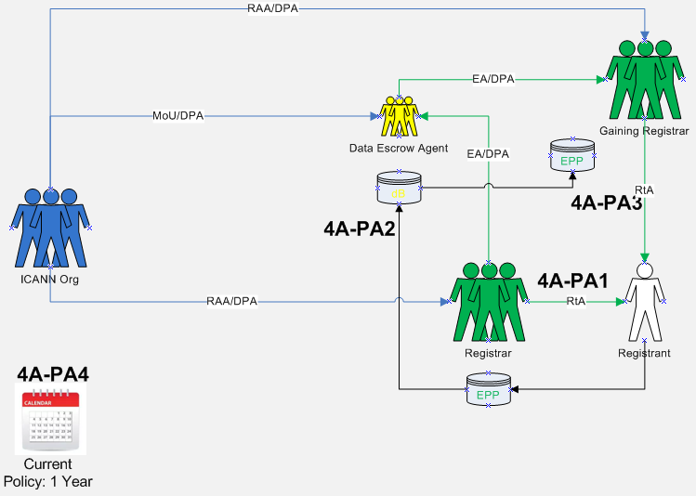

PURPOSE:
--For Registrars Only--
Provide mechanisms for safeguarding Registered Name Holders’ Registration Data in the event of a business or technical failure of a Registrar or Registry Operator, or unavailability of a Registrar or Registry Operator, as described in the RAA and RA, respectively.

Data Elements Matrix:
R = required
O-RNH, O-Rr, O-CP = optional
N/A=not applicable

Data Element  (Collected & Generated*) | Collection  4A-PA1 | Transmission  4A-PA2 | Disclosure  4A-PA3
Domain Name | R | R | R
Registry Domain ID*
Registrar Whois Server*
Registrar URL*
Updated Date*
Creation Date*
Registry Expiry Date*
Registrar Registration Expiration Date* | O-Rr | R | R
Registrar* | R | R | R
Registrar IANA ID*
Registrar Abuse Contact Email*
Registrar Abuse Contact Phone*
Reseller* | O-Rr | R | R
Domain Status(es)*
Registry Registrant ID*
Registrant Fields
• Name | R | R | R
• Organization (opt.)
• Street | R | R | R
• City | R | R | R
• State/province | R | R | R
• Postal code | R | R | R
• Country | R | R | R
• Phone | R | R | R
• Phone ext (opt.)
• Fax (opt.)
• Fax ext (opt.)
• Email | R | R | R
2nd E-Mail address
Admin ID*
Admin Fields
• Name
• Organization (opt.)
• Street
• City
• State/province
• Postal code
• Country
• Phone
• Phone ext (opt.)
• Fax (opt.)
• Fax ext (opt.)
• Email
Tech ID*
Tech Fields
• Name
• Organization (opt.)
• Street
• City
• State/province
• Postal code
• Country
• Phone
• Phone ext (opt.)
• Fax (opt.)
• Fax ext (opt.)
• Email
NameServer(s)
DNSSEC
Name Server IP Address
Last Update of Whois Database*

4B | PURPOSE:  --For Registries Only--  Provide mechanisms for safeguarding Registered Name Holders’ Registration Data in the event of a business or technical failure of a Registrar or Registry Operator, or unavailability of a Registrar or Registry Operator, as described in the RAA and RA, respectively.
Purpose Rationale:
1) If the purpose is based on an ICANN contract, cite the relevant section of the ICANN contracts that corresponds to the above purpose, if any.

- Registry EBERO Program - https://www.icann.org/resources/pages/ebero-2013-04-02-en
- Registry Data Escrow Specification: https://newgtlds.icann.org/sites/default/files/agreements/agreement-approved-31jul17-en.html#specification2
- Data Fields Sources:
  - http://tools.ietf.org/html/draft-arias-noguchi-registry-data-escrow
  - https://tools.ietf.org/html/draft-arias-noguchi-dnrd-objects-mapping-09

Escrowing the data is supported by ICANN’s mandate to provide for security and stability in the DNS and this purpose is primarily protecting the registrant’s rights. Escrow exists because Registrants have a reasonable expectation of business continuity.

It is reasonable to expect that a DPA would consider the escrow of customer data critical to the delivery of the service being provided to be common business practice and legal under GDPR provided appropriate contractual relationships are in place with the escrow agent to ensure that the data, once transferred to the escrow agent is afforded appropriate protection.

While technical and business resiliency could be achieved via other mechanisms, the escrow of data necessary to deliver the service is a generally accepted practice that is likely to be considered necessary to achieve the purpose of “…safeguarding registered name holder’s registration data in the event of a business or technical failure, or other unavailability…”

While all contracted parties that have to be compliant with GDPR need to make sure there are protections against data loss and mechanisms to enable swift data recovery, ICANN is operating at the global level where customers can register domain names with registrars globally and the registry operators are based in numerous jurisdictions, it is important to have interoperability of escrow agents. Requiring all contracted parties to use the same policies for both escrowing data and applying the same standards to escrow agents for making data available, is necessary for contingency planning at the global level.

Within the Temporary Specification, EBERO is mentioned as Processing Activity under Appendix C. The Charter Question, Part 2i, tasks the EPDP to consider if this Processing Activity should be eliminated or adjusted. Based on initial research of the EBERO process, Registry Escrow is invoked as a component of the overall process with no indication that registration data other than what is identified here is transferred within any of the other EBERO components. The EPDP concluded that documentation of EBERO can be satisfied within the processing activities defined for this purpose of Registry Escrow.

2) Is the purpose in violation with ICANN's bylaws?

No, providing a safety net for registrants in the event of registry technical of business failure seems within ICANN’s remit.

1.1(a)(i) Coordinates the allocation and assignment of names in the root zone of the Domain Name System ("DNS") and coordinates the development and implementation of policies concerning the registration of second-level domain names in generic top-level domains ("gTLDs"). In this role, ICANN's scope is to coordinate the development and implementation of policies:
- For which uniform or coordinated resolution is reasonably necessary to facilitate the openness, interoperability, resilience, security and/or stability of the DNS including, with respect to gTLD registrars and registries, policies in the areas described in Annex G-1 and Annex G-2; and
- That are developed through a bottom-up consensus-based multistakeholder process and designed to ensure the stable and secure operation of the Internet's unique names systems.
The issues, policies, procedures, and principles addressed in Annex G-1 and Annex G-2 with respect to gTLD registrars and registries shall be deemed to be within ICANN's Mission.

3) Are there any “picket fence” considerations related to this purpose?

Only with respect to the data model(s) defined within RDDS/Whois consensus policies. Agreements between ICANN and Data Escrow Providers are not within scope of the picket fence.

Lawfulness of Processing Test:
Processing Activity: | Responsible Party:  (Charter Questions 3k, 3l, 3m) | Lawful Basis: (Is the processing necessary to achieve the purpose?)
4B-PA1: Collection of registration data by Registry  (Charter Question 2b) | ICANN  Registries | 6(1)(f)  This Processing Activity of Collection is not required to be documented within the Purpose for Registry Escrow because the processing activity for transmission of registration data to the Data Escrow Agent (as noted below) has already been collected or generated from other ICANN Purposes that also contain Processing Activities for the transfer of registration data from the Registrar to the Registry.  However, the transparency of collection to the Registrant/Data Subject for the purpose of escrow is required. Refer to the Purpose for establishing the rights of the Registered Name Holder.
4B-PA2: Transmission of registration data to Data Escrow Agent  (Charter Questions 2c, 2d, 2e, 2i) | ICANN  Registries  Data Escrow Agent | This is a 6(1)(f) lawful basis because although there is likely a legitimate interest in providing mechanisms for safeguarding Registered Name Holders' Registration Data in the event of a business or technical failure, or other unavailability of a Registrar or Registry Operator, it is not technically necessary to transmit data to an escrow agent in order to allocate a string to a registered name holder, and is therefore not necessary to perform the registration contract.
4B-PA3: Disclosure of registration data to EBERO Provider  (Charter Questions 2f (gating questions), 2j) | ICANN  Data Escrow Agent  EBERO Provider | This is a 6(1)(f) lawful basis because although there is likely a legitimate interest in providing mechanisms for safeguarding Registered Name Holders' Registration Data in the event of a business or technical failure, or other unavailability of a Registrar or Registry Operator, it is not technically necessary to transmit data to an escrow agent in order to allocate a string to a registered name holder, and is therefore not necessary to perform the registration contract.  Specification 2, Part B “Legal Requirements”, #6 under “Integrity and Confidentiality” stipulates how the release of a deposit is made.  How and who ICANN chooses as the EBERO Provider may have additional implications to the lawfulness should the EBERO Provider not reside within the EU when the Losing Registry did reside within the EU.
4B-PA4: Disclosure of registration data to Gaining Registry  (Charter Questions 2f (gating questions), 2j) | ICANN  EBERO Provider  Gaining Registry | This is a 6(1)(f) lawful basis because although there is likely a legitimate interest in providing mechanisms for safeguarding Registered Name Holders' Registration Data in the event of a business or technical failure, or other unavailability of a Registrar or Registry Operator, it is not technically necessary to transmit data to an escrow agent in order to allocate a string to a registered name holder, and is therefore not necessary to perform the registration contract.  Specification 2, Part B “Legal Requirements”, #6 under “Integrity and Confidentiality” stipulates how the release of a deposit is made.
4B-PA5: Retention of registration data by Data Escrow Agent  Note, this PA is not represented on the data elements table, because data processed above represents what data elements will be retained  (Charter Questions 2g) | ICANN  Data Escrow Agent | This is a 6(1)(f) lawful basis due to the connection between the Retention processing activity with that of the Transmission of registration data to the Data Escrow Agent from the Registry.  Specification 2, Part B “Legal Requirements”, #4 under “Integrity and Confidentiality” stipulates “(iii) keep and safeguard each Deposit for one (1) year.”  Once a full escrow deposit has been successfully received and validated by the escrow agent, any previous deposits are obsolete and of no value. In the event of differential deposits, a 1-week retention would be required. The working group recommends that a 1 month minimum retention period by the escrow agent be established to provide an additional buffer against technical failure by the escrow agent.
4B-PA6: Retention of registration data by EBERO Provider  Note, this PA is not represented on the data elements table, because data processed above represents what data elements will be retained  (Charter Questions 2g) | ICANN  EBERO Provider | This processing activity needs to be investigated further. Refer to language listed under 4B-PA5.  Current policy is one year.

Data Flow Map:
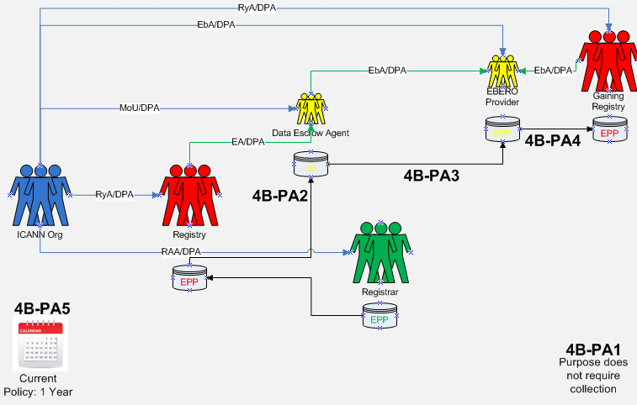

PURPOSE:
--For Registries Only--
Provide mechanisms for safeguarding Registered Name Holders’ Registration Data in the event of a business or technical failure of a Registrar or Registry Operator, or unavailability of a Registrar or Registry Operator, as described in the RAA and RA, respectively.

Data Elements Matrix:
R = required
O-RNH, O-Rr, O-CP = optional
N/A=not applicable

Data Element  (Collected & Generated*) | Collection  4B-PA1 | Transmission  4B-PA2 | Disclosure  4B-PA3 | Disclosure  4B-PA4
Domain Name | R | R | R | R
Registry Domain ID* | R | R | R | R
Registrar Whois Server* | R | R | R | R
Registrar URL* | R | R | R | R
Updated Date* | R | R | R | R
Creation Date* | R | R | R | R
Registry Expiry Date* | R | R | R | R
Registrar Registration Expiration Date* | O-CP | O-CP | O-CP | O-CP
Registrar* | R | R | R | R
Registrar IANA ID* | R | R | R | R
Registrar Abuse Contact Email* | R | R | R | R
Registrar Abuse Contact Phone* | R | R | R | R
Reseller* | O-CP | O-CP | O-CP | O-CP
Domain Status(es)* | R | R | R | R
Registry Registrant ID* | R | R | R | R
Registrant Fields
• Name | O-CP | O-CP | O-CP | O-CP
• Organization (opt.) | O-CP | O-CP | O-CP | O-CP
• Street | O-CP | O-CP | O-CP | O-CP
• City | O-CP | O-CP | O-CP | O-CP
• State/province | O-CP | O-CP | O-CP | O-CP
• Postal code | O-CP | O-CP | O-CP | O-CP
• Country | O-CP | O-CP | O-CP | O-CP
• Phone | O-CP | O-CP | O-CP | O-CP
• Phone ext (opt.) | O-CP | O-CP | O-CP | O-CP
• Fax (opt.) | O-CP | O-CP | O-CP | O-CP
• Fax ext (opt.) | O-CP | O-CP | O-CP | O-CP
• Email | O-CP | O-CP | O-CP | O-CP
2nd E-Mail address
Admin ID*
Admin Fields
• Name
• Organization (opt.)
• Street
• City
• State/province
• Postal code
• Country
• Phone
• Phone ext (opt.)
• Fax (opt.)
• Fax ext (opt.)
• Email
Tech ID*
Tech Fields
• Name | O-CP | O-CP | O-CP | O-CP
• Organization (opt.)
• Street
• City
• State/province
• Postal code
• Country
• Phone | O-CP | O-CP | O-CP | O-CP
• Phone ext (opt.)
• Fax (opt.)
• Fax ext (opt.)
• Email | O-CP | O-CP | O-CP | O-CP
NameServer(s) | O-RNH | O-RNH | O-RNH | O-RNH
DNSSEC | O-RNH | O-RNH | O-RNH | O-RNH
Name Server IP Address | O-RNH | O-RNH | O-RNH | O-RNH
Last Update of Whois Database*

5 | PURPOSE:  i) Handle contractual compliance monitoring requests and audit activities consistent with the terms of the Registry agreement and the Registrar accreditation agreements and any applicable data processing agreements, by processing specific data only as necessary;  i) Handle compliance complaints initiated by ICANN, or third parties consistent with the terms of the Registry agreement and the Registrar accreditation agreements.
Purpose Rationale:
1) If the purpose is based on an ICANN contract, cite the relevant section of the ICANN contracts that corresponds to the above purpose, if any.

RA - https://newgtlds.icann.org/sites/default/files/agreements/agreement-approved-31jul17-en.html
Registry:
2.2 Compliance with Consensus Policies and Temporary Policies
2.11 Contractual and Operational Compliance Audits
Specification 4, 3.1 Periodic Access to Thin Registration Data
Specification 11 Public Interest Commitments

RAA - https://www.icann.org/resources/pages/approved-with-specs-2013-09-17-en
Registrar:
Registrar Obligations - 3.4.3, 3.7.7
3.15 Registrar Self-Assessment and Audits
4.1 Compliance with Consensus Policies and Temporary Policies
Data Retention Specification, 2.

If a contractual compliance complaint is filed, the complainant provides certain information regarding the issue, which may contain personal data. Depending on the nature of the issue, ICANN Compliance may ask the Registrar or Registry Operator for the minimum data needed to investigate the complaint. Compliance may also look at the public WHOIS to supplement its review or processing.

For ICANN Contractual Compliance audits, ICANN sends audit questionnaires to Registry Operators and Registrars. In responding to the questionnaire, the Registry Operator and Registrar could include personal data in its responses. Further, to allow ICANN to carry out accuracy audits of registration contact data, ICANN may request from Registry Operators and Registrars the minimum data for randomly selected registrations.

Also, as part of Registry Operator audits, ICANN Contractual Compliance requests escrowed data to cross-reference information between data escrow and zone file and bulk registration data access for a sample of 25 domain names to ensure consistency.

2) Is the purpose in violation with ICANN's bylaws?

No. Per ICANN’s Mission, Section 1.1(a)(i):
“..In this role, ICANN's scope is to coordinate the development and implementation of policies:
....That are developed through a bottom-up consensus-based multistakeholder process and designed to ensure the stable and secure operation of the Internet's unique names systems.
..The issues, policies, procedures, and principles addressed in Annex G-1 and Annex G-2 with respect to gTLD registrars and registries shall be deemed to be within ICANN's Mission.”

3) Are there any “picket fence” considerations related to this purpose?

No. Registration Directory Services is within the “picket fence” as noted in ICANN Mission and Bylaws and contracts with ICANN to Registries and Registrars.

Lawfulness of Processing Test:
Processing Activity: | Responsible Party:  (Charter Questions 3k, 3l, 3m) | Lawful Basis: (Is the processing necessary to achieve the purpose?)
5-PA1: Collection of registration data for compliance with ICANN contracts  (Charter Question 2b) | ICANN  Registrars  Registries | This is a 6(1)(f) purpose because although there may be a legitimate interest in collecting registration data for ICANN org compliance to confirm compliance with the RAA/RA, this collection is not technically necessary to perform the registration contract.  The BC and IPC disagree that Purpose 5 is a 6(1)(f) purpose. The Team tentatively agreed to the following: (a) 6(1)(f) is an appropriate legal basis for the compliance purpose; (b) Some (BC and IPC) believe Purpose F may be a 6(1)(b); (c) There are concerns that 6(1)(f) may cause issues where the controller determines that the privacy rights outweigh the legitimate interest and therefore data cannot be provided.
5-PA2: Transmission of registration data from Registrar to Registry  (Charter Questions 2c, 2d, 2e, 2i) | N/A | The transfer of data from the Registrar to the Registry is not necessary to fulfill this purpose because ICANN Org will contact the Registrar or Registry as necessary to acquire the data needs to investigate complaints.
5-PA3: Transmission of registration data to ICANN org  (Charter Questions 2c, 2d, 2e, 2i) | N/A | This is a 6(1)(f) purpose because although there may be a legitimate interest in transmitting registration data to ICANN org compliance to confirm compliance with the RAA/RA, this transmission is not technically necessary to perform the registration contract.  (Note: the requisite balancing test must be performed for each third-party type of disclosure and not for all registration data all the time.)
5-PA4: Disclosure of registration data  (Charter Questions 2f (gating questions), 2j) | N/A | N/A  This processing activity is not applicable. The disclosure of this data to ICANN org occurs in 5-PA3 when the data is transferred from the Registrar or Registry.
5-PA5: Retention of registration data by ICANN org  Note, this PA is not represented on the data elements table, because data processed above represents what data elements will be retained  (Charter Questions 2g) | ICANN | May go beyond the life of registration in order to complete accuracy audit and compliance processing, not to exceed one year.

Data Flow Map:
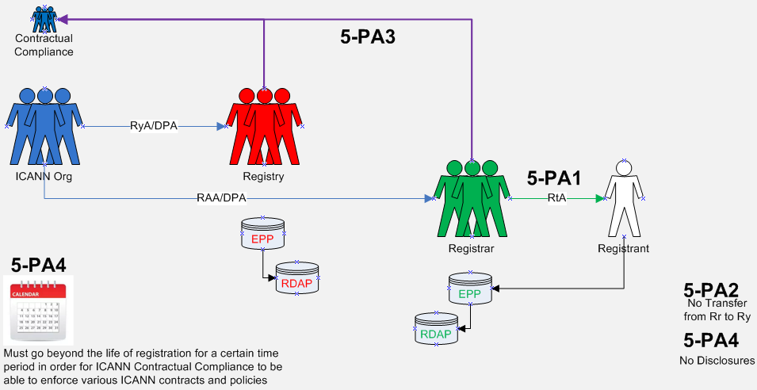

PURPOSE:
i) Handle contractual compliance monitoring requests and audit activities consistent with the terms of the Registry agreement and the Registrar accreditation agreements and any applicable data processing agreements, by processing specific data only as necessary;
ii) Handle compliance complaints initiated by ICANN, or third parties consistent with the terms of the Registry agreement and the Registrar accreditation agreements.

Data Elements Matrix:
R = required
O-RNH, O-Rr, O-CP = optional
N/A=not applicable

Data Element  (Collected & Generated*) | Collection  5-PA1 | Transmission  5-PA2 | Transmission (to ICANN)  5-PA3 | Disclosure (to ICANN)  5-PA4
Domain Name |  |  | R | R
Registry Domain ID* |  |  | R | R
Registrar Whois Server* |  |  | R | R
Registrar URL* |  |  | R | R
Updated Date* |  |  | R | R
Creation Date* |  |  | R | R
Registry Expiry Date* |  |  | R | R
Registrar Registration Expiration Date* |  |  | R | R
Registrar* |  |  | R | R
Registrar IANA ID* |  |  | R | R
Registrar Abuse Contact Email* |  |  | R | R
Registrar Abuse Contact Phone* |  |  | R | R
Reseller* |  |  | R | R
Domain Status(es)* |  |  | R | R
Registry Registrant ID* |  |  | R | R
Registrant Fields
• Name |  |  | R | R
• Organization (opt.) |  |  | R | R
• Street |  |  | R | R
• City |  |  | R | R
• State/province |  |  | R | R
• Postal code |  |  | R | R
• Country |  |  | R | R
• Phone |  |  | R | R
• Phone ext (opt.) |  |  | R | R
• Fax (opt.) |  |  | R | R
• Fax ext (opt.) |  |  | R | R
• Email |  |  | R | R
2nd E-Mail address
Admin ID*
Admin Fields
• Name
• Organization (opt.)
• Street
• City
• State/province
• Postal code
• Country
• Phone
• Phone ext (opt.)
• Fax (opt.)
• Fax ext (opt.)
• Email
Tech ID* |  |  | R | R
Tech Fields
• Name |  |  | R | R
• Organization (opt.)
• Street
• City
• State/province
• Postal code
• Country
• Phone |  |  | R | R
• Phone ext (opt.)
• Fax (opt.)
• Fax ext (opt.)
• Email |  |  | R | R
NameServer(s) |  |  | R | R
DNSSEC |  |  | R | R
Name Server IP Address |  |  | R | R
Last Update of Whois Database* |  |  | R | R

6 | PURPOSE:  Operationalize policies for the resolution of disputes regarding or relating to the registration of domain names (as opposed to the use of such domain names, but including where such policies take into account use of the domain names), namely the UDRP, URS, PDDRP, RRDRP, and the TDRP.
Purpose Rationale:
1) If the purpose is based on an ICANN contract, cite the relevant section of the ICANN contracts that corresponds to the above purpose, if any.

- RAA - https://www.icann.org/resources/pages/approved-with-specs-2013-09-17-en
  - Section 3.8
- RyA - https://newgtlds.icann.org/sites/default/files/agreements/agreement-approved-31jul17-en.html
  - Specification 7

ICANN Org to provide EPDP Team with copy of agreements with UDRP/URS providers in relation to data protection / transfer of data as well as the relevant data protection policies that dispute resolution providers have in place.

Rights Protection Mechanisms (RPMs) provisions exist within both the Registry and Registrar agreements as connected to ICANN Bylaws. This purpose is connected to Rights Protection Mechanisms of Uniform Dispute Resolution Mechanism (UDRP) and Uniform Rapid Suspension (URS), but it does not preclude RPMs that could be created or modified in the future.

RRDRP and PDDRP RPMs were also considered whether they should be connected to this purpose. Because these DRPs have not been tested, their inclusion here is to act as a marker for future consideration if/when they are used.

2) Is the purpose in violation with ICANN's bylaws?

No.

ICANN bylaws, Section 1.1(a)(i), as a part of “Mission” refer to Annexes G1 and G2. Annex G-1 contains a provision for Registrars, “resolution of disputes regarding the registration of domain names (as opposed to the use of such domain names, but including where such policies take into account use of the domain names)” Annex G-2 also contains, “resolution of disputes regarding the registration of domain names (as opposed to the use of such domain names)”.

3) Are there any “picket fence” considerations related to this purpose?

Resolution of disputes regarding or relating to the registration of domain names (as opposed to the use of such domain names) are considered within the picket fence for the development of consensus policies. The purpose and the processing hereunder, as specified by the collection, transmission and disclosure of the data elements identified, are considered within the picket fence based upon the coordination, operationalization and facilitation of the dispute resolution mechanisms listed. The Temp Spec (Appendix D & E) now makes reference to who an RPM provider must contact based on Thick or Thin RDS to obtain registration data for the complaint.

Lawfulness of Processing Test:
Processing Activity: | Responsible Party:  (Charter Questions 3k, 3l, 3m) | Lawful Basis: (Is the processing necessary to achieve the purpose?)
6-PA1: Collection of registration data to implement the UDRP, URS and TDRP  (Charter Question 2b) | ICANN  Registrars | This is a 6(1)(b) purpose because it is necessary to collect registration data in order to implement a UDRP or URS decision. For example, in the case of a UDRP/URS proceeding, the Registrant must agree to be bound by the UDRP/URS in order to register a domain name, so the collection of data for this purpose is necessary to fulfill the registration agreement.
 | ICANN  Registries | This is a 6(1)(f) purpose because ICANN and Registries do not have a direct contract with the registrant. The Registry must process data to fulfill its obligations regarding the RPMs, compliance with which are incorporated into the Registry Agreement.  Under Article 6(1)(f) with regard to the URS and UDRP for registries and ICANN, because the processing is necessary for the purposes of pursued legitimate interests that are not overridden by the interests or fundamental rights and freedoms of the data subject. With regard to this balancing test, we note that the contacts are important to ensure due process for the registrant so that they have notice of the proceedings and can avoid losing their domain name through a default.  Note Registries collect this data as required per existing URS Rules and Procedures.
6-PA1Z: Collection of registration data to implement the RDDRP and PDDRP  Note: these two DRPs are not represented on the data elements table below.  (Charter Question 2b) | ICANN  Registries  Registrars | This is a 6(1)(f) with regard to the RDDRP and PDDRP for registrars, registries, and ICANN, because the processing is necessary for the purposes of pursued legitimate interests that are not overridden by the interests or fundamental rights and freedoms of the data subject.
6-PA2: Transmission of registration data from Registrar to Registry  (Charter Questions 2c, 2d, 2e, 2i) | ICANN  Registrars | This is a 6(1)(b) purpose because transmission of (at least minimal) registration data from the Registrar to the Registry is necessary to identify the Registrant for purposes of dispute resolution.
 | ICANN  Registries | This is a 6(1)(f) purpose because although there is a legitimate interest in transmitting registration data to the Registry, this transmission is not technically necessary to perform the registration contract. The Registry must process data to fulfill its obligations regarding the RPMs and DRPs, compliance with which are incorporated into the Registry Agreement.
6-PA3: Transmission of registration data to Dispute Resolution Provider to administer the UDRP, URS, & TDRP  (Charter Questions 2c, 2d, 2e, 2i) | ICANN  Registrars  Registries  Dispute Resolution Provider | 6(1)(b) for Registrars  6(1)(f) for Registries and ICANN  This is a 6(1)(f) purpose because although there may be a legitimate interest in transmitting registration data to Dispute Resolution Providers, this transmission is not technically necessary to perform the registration contract.
6-PA3Z: Transmission of registration data to Dispute Resolution Provider to administer the RDDRP and PDDRP  Note: these two DRPs are not represented on the data elements table below.  (Charter Questions 2c, 2d, 2e, 2i) | ICANN  Registrars  Registries  Dispute Resolution Provider | 6(1)(b) for Registrars  6(1)(f) for Registries and ICANN  This is a 6(1)(f) purpose because although there may be a legitimate interest in transmitting registration data to Dispute Resolution Providers, this transmission is not technically necessary to perform the registration contract.
6-PA4: Disclosure of registration data used for complaints to Complainant  (Charter Questions 2f (gating questions), 2j) | ICANN  Dispute Resolution Provider  Complainant | 6(1)(f). This activity allows for the filing of John Doe complaints and the ability to amend the complaint as needed with the proper Registrant data so that the proceeding can go forward. The provision of this data to the complainant is important to help ensure due process for the registrant: it allows the complainant to withdraw a URS/UDRP claim where it becomes clear from the identity of the registrant that they have a right or legitimate interest to use the name, or that they have not registered the name in bad faith. It also enables, in some circumstances, requests to consolidate related claims, which has cost-saving benefits for all parties. In addition, the provision of this information to complainants supports case settlement (roughly 20% of cases) saving all parties time and expense.
6-PA5: Publication of registration data used for complaints on Dispute Resolution Provider websites to Internet Users  (Charter Questions 2f (gating questions), 2j) | ICANN  Dispute Resolution Provider  Internet Users | 6(1)(f)  WIPO’s GDPR FAQ: Paragraph 4(j) of the UDRP mandates that “[a]ll (successful and unsuccessful) decisions under this Policy will be published in full over the Internet, except when an Administrative Panel determines in an exceptional case to redact portions of its decision.” In this respect, through their acceptance of the applicable registration terms and conditions, domain name registrants subject to a UDRP proceeding are bound by this provision as well as the other UDRP terms. Publication of party names in UDRP decisions is essential to the overall functioning of the UDRP in that it helps to explain the panel’s findings, supports jurisprudential consistency, facilitates the conduct of other cases as appropriate, and furthermore can provide a deterrent effect. Against the background of the above-mentioned purposes, any request to redact a party’s name from a decision should normally be submitted for the panel’s consideration during the UDRP proceeding. Also in light of the above-mentioned reasons for full decision publication, any such request should be appropriately motivated.
6-PA6: Retention of registration data used for complaints by Dispute Resolution Providers  Note, this PA is not represented on the data elements table, because data processed above represents what data elements will be retained  (Charter Questions 2g) | ICANN  Dispute Resolution Provider | 6(1)(f)  The EPDP Team is not aware of any current data retention requirements by dispute resolution providers.  Retention of full registration data (See 6-PA3) by the Provider after the complaint has closed:  Retention Period: TBD based on DRP data protection policies and transfer agreements in place between DRPs and ICANN.  Retention of Complainant and Respondent data (See 6-PA5) such as Domain Name, Registrar, Name, Organization, City, State Country, on the Provider Site displaying closed complaints:  Retention Period: TBD based on DRP data protection policies and transfer agreements in place between DRPs and ICANN.
6-PA7: Retention of registration data used for complaints by Complainants  Note, this PA is not represented on the data elements table, because data processed above represents what data elements will be retained  (Charter Questions 2g) | ICANN  Dispute Resolution Provider | This processing activity is listed because the role of the Complainant is defined in the Processing Activity 6-PA4.  The IPC believes this Processing Activity is out of scope and should be deleted. This has yet to be explored in detail by the EPDP Plenary.

Data Flow Map:
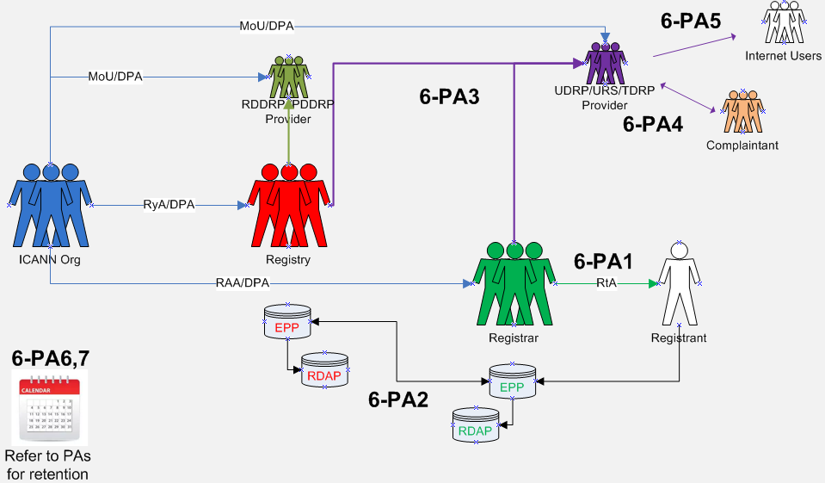
PURPOSE:
Operationalize policies for the resolution of disputes regarding or relating to the registration of domain names (as opposed to the use of such domain names, but including where such policies take into account use of the domain names), namely the UDRP, URS, PDDRP, RRDRP, and the TDRP.

Data Elements Matrix:
R = required
O-RNH, O-Rr, O-CP = optional
N/A=not applicable

Data Element  (Collected & Generated*) | Collection  6-PA1 | Transmission  6-PA2 | Transmission  6-PA3 | Disclosure  6-PA4 | Publication  6-PA5
Domain Name |  |  | R | R | R
Registry Domain ID*
Registrar Whois Server* |  |  | R | R
Registrar URL* |  |  | R | R
Updated Date* |  |  | R | R
Creation Date* |  |  | R | R
Registry Expiry Date* |  |  | R | R
Registrar Registration Expiration Date* |  |  | O-Rr | O-Rr
Registrar* |  |  | R | R | R
Registrar IANA ID* |  |  | R | R
Registrar Abuse Contact Email* |  |  | R | R
Registrar Abuse Contact Phone* |  |  | R | R
Reseller* |  |  | O-Rr | O-Rr
Domain Status(es)* |  |  | R | R
Registry Registrant ID*
Registrant Fields
• Name |  |  | R | R | R
• Organization (opt.) |  |  | R | R | R
• Street |  |  | R | R
• City |  |  | R | R | R
• State/province |  |  | R | R | R
• Postal code |  |  | R | R
• Country |  |  | R | R | R
• Phone |  |  | R | R
• Phone ext (opt.) |  |  | R | R
• Fax (opt.) |  |  | R | R
• Fax ext (opt.) |  |  | R | R
• Email |  |  | R | R
2nd E-Mail address
Admin ID*
Admin Fields
• Name
• Organization (opt.)
• Street
• City
• State/province
• Postal code
• Country
• Phone
• Phone ext (opt.)
• Fax (opt.)
• Fax ext (opt.)
• Email
Tech ID*
Tech Fields
• Name
• Organization (opt.)
• Street
• City
• State/province
• Postal code
• Country
• Phone
• Phone ext (opt.)
• Fax (opt.)
• Fax ext (opt.)
• Email
NameServer(s) |  |  | R | R
DNSSEC
Name Server IP Address
Last Update of Whois Database*

7 | PURPOSE:  Enabling validation to confirm that Registered Name Holder meets gTLD registration policy eligibility criteria voluntarily adopted by Registry Operator and that are described or referenced in the Registry Agreement for that gTLD.
Purpose Rationale:
1) If the purpose is based on an ICANN contract, is this lawful as tested against GDPR and other laws?

Yes. Registry Agreement allows Registry Operators to establish, publish, and adhere to clear registration policies (e.g., Spec. 11, 3(d); Spec. 12; Spec. 13). See also ICANN Bylaws (Art. 1.1(a)(i) and Annex G-2).
Enabling validation to confirm that Registered Name Holder meets registration policy eligibility criteria introduces innovation and differentiation in the gTLD space.

2) Is the purpose in violation with ICANN's bylaws?

No. This purpose is consistent with ICANN’s Mission of coordinating the development and implementation of policies concerning the registration of second-level domain names in gTLDs (Introduction of New gTLDs and Applicant Guidebook), and principles for allocation of registered names in a TLD (Annex G-2)

3) Are there any “picket fence” considerations related to this purpose?

This purpose is related to WHOIS, which is within the Picket Fence. Specifically, Specification 1 of the Registry Agreement (Section 3.1(b)(iv) and (v) and Specification 4 of the Registrar Accreditation Agreement both refer to categories of issues and principles of allocation of registered names in a TLD.

Lawfulness of Processing Test:
Processing Activity: | Responsible Party:  (Charter Questions 3k, 3l, 3m) | Lawful Basis: (Is the processing necessary to achieve the purpose?)
7-PA1: Collecting specific data for Registry Agreement-mandated eligibility requirements  (Charter Question 2b) | Registries | 6(1)(b) (for ICANN, registrars- or Registry-mandated eligibility requirements) because it is necessary to collect specific Registrant data to confirm the registrant meets the specific requirements of the registration agreement, i.e., registrar needs to verify the registrant is a licensed attorney to register a .abogado domain name.  6(1)(f) for Registries, which are not parties to the registration agreement, but process the data in accordance with the obligations under the Registry-Registrar Agreement to allocate and activate domain names for registered name holders that meet the registration policy eligibility requirements
7-PA2: Collecting specific data for Registry Operator-adopted eligibility requirements  (Charter Question 2b) | Registries | 6(1)(b) for Registrars because it is necessary to collect specific registrant data to confirm the registrant meets the specific requirements of the registration agreement, i.e., registrar needs to verify the registrant is a licensed attorney to register a .abogado domain name  6(1)(f) for Registries, which are not parties to the registration agreement, but process the data in accordance with the obligations under the Registry-Registrar Agreement to allocate and activate domain names for Registered Name Holders that meet the registration policy eligibility requirements
7-PA3: Transfer of registration data from registrar to registry  (Charter Questions 2c, 2d, 2e, 2i) | RA-mandated eligibility requirements  Registries | 6(1)(b) for Registrars because transfer from Registrar to Registry of registration data elements that demonstrate satisfaction of registration policy eligibility criteria is necessary so that the registry may validate satisfaction of eligibility criteria, and comply with ICANN audit requests.  6(1)(f) for Registries. The transfer is necessary so that the Registry may validate satisfaction of eligibility criteria and comply with ICANN audit requests.
7-PA4: Transfer of registration data from registrar to registry  (Charter Questions 2c, 2d, 2e, 2i) | Registry-adopted eligibility requirements  Registries | 6(1)(b) for registrars because transfer from registrar to registry of registration data elements that demonstrate satisfaction of registration policy eligibility criteria is necessary so that the registry may validate satisfaction of eligibility criteria.  6(1)(f) for registries. The transfer is necessary so that the registry may validate satisfaction of eligibility criteria and comply with ICANN audit requests.
7-PA5: Disclosure of registration data to Internet Users  (Charter Questions 2f (gating questions), 2j) | Registries | A lawful basis needs to be further investigated and can vary depending on the eligibility requirement.  Some Registry Operators, as part of their business model, may require the publication as part of their eligibility requirements and perhaps published in the freely available RDDS as noted under Purpose 3.
7-PA6: Retention of registration data  Note, this PA is not represented on the data elements table, because data processed above represents what data elements will be retained  (Charter Questions 2g) | Registries | 6(1)(f)  Life of registration.

Data Flow Map:
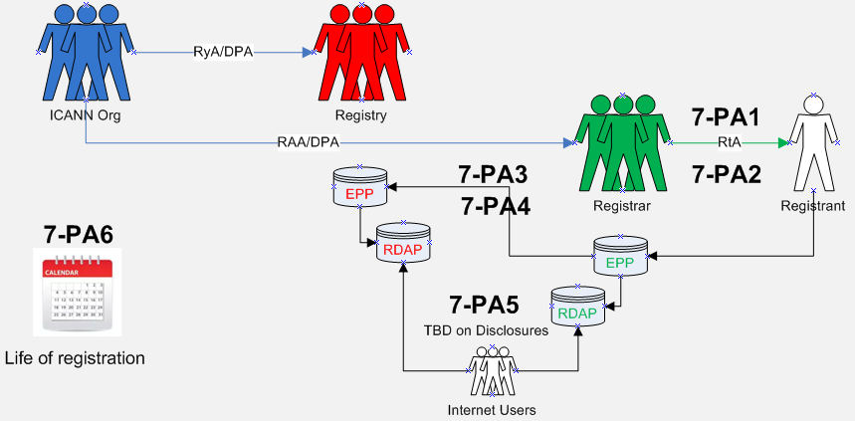

PURPOSE:
Enabling validation to confirm that Registered Name Holder meets gTLD registration policy eligibility criteria voluntarily adopted by Registry Operator and that are described or referenced in the Registry Agreement for that gTLD.

Data Elements Matrix:
R = required
O-RNH, O-Rr, O-CP = optional
N/A=not applicable

Data Element  (Collected & Generated*) | Collection  7-PA1 | Collection  7-PA2 | Transmission  7-PA3 | Transmission  7-PA4 | Disclosure  7-PA5
Domain Name
Registry Domain ID*
Registrar Whois Server*
Registrar URL*
Updated Date*
Creation Date*
Registry Expiry Date*
Registrar Registration Expiration Date*
Registrar*
Registrar IANA ID*
Registrar Abuse Contact Email*
Registrar Abuse Contact Phone*
Reseller*
Domain Status(es)*
Registry Registrant ID*
Registrant Fields
∙ Name
∙ Organization (opt.)
∙ Street
∙ City
∙ State/province
∙ Postal code
∙ Country
∙ Phone
∙ Phone ext (opt.)
∙ Fax (opt.)
∙ Fax ext (opt.)
∙ Email
2nd E-Mail address
Admin ID*
Admin Fields
∙ Name
∙ Organization (opt.)
∙ Street
∙ City
∙ State/province
∙ Postal code
∙ Country
∙ Phone
∙ Phone ext (opt.)
∙ Fax (opt.)
∙ Fax ext (opt.)
∙ Email
Tech ID*
Tech Fields
∙ Name
∙ Organization (opt.)
∙ Street
∙ City
∙ State/province
∙ Postal code
∙ Country
∙ Phone
∙ Phone ext (opt.)
∙ Fax (opt.)
∙ Fax ext (opt.)
∙ Email
NameServer(s)
DNSSEC
Name Server IP Address
Last Update of Whois Database*
Other Data:
∙ Additional data elements as identified by Registry Operator in its registration policy, such as (i) status as Registry Operator Affiliate or Trademark Licensee [.MICROSOFT]; (ii) membership in community [.ECO]; (iii) licensing, registration or appropriate permits (.PHARMACY, .LAW] place of domicile [.NYC]; (iv) business entity or activity [.BANK, .BOT] | O-CP | O-CP | O-CP | O-CP | O-CP

Not ALL data are necessarily required to be disclosed. The data elements represented in the workbooks are an aggregate of which data may be disclosed, but specific elements are yet to be determined depending on the situation.
“Registrar Whois Server”, “Registrar URL”, “Registrar Abuse Contact Email” and “Registrar Abuse Contact Phone” are not transmitted to the registry with each registration in EPP; they are provided to the registry once by each registrar and used for each registration a registrar has. I’m not sure if you want to flag this or not.
“Domain Status” (which is a field that can appear multiple times) may or may not be set by the registrar; some status are set by the registrar, some are set by the registry.
“Registrar Whois Server”, “Registrar URL”, “Registrar Abuse Contact Email” and “Registrar Abuse Contact Phone” are not transmitted to the registry with each registration in EPP; they are provided to the registry once by each registrar and used for each registration a registrar has. I’m not sure if you want to flag this or not.
“Domain Status” (which is a field that can appear multiple times) may or may not be set by the registrar; some status are set by the registrar, some are set by the registry.
Per the current temp spec requirement: 2.5.1. Registrar MUST provide an email address or a web form to facilitate email communication with the relevant contact, but MUST NOT identify the contact email address or the contact itself.
Refer to recommendation #8 in regards to redaction and more information pertaining to a minimum public data set.
idem
Refer to Recommendation #13 about publication and redaction of the Organization field
Refer to Recommendation #12 about the redaction of the city field.
Refer to recommendation #14 about how web forms and email addresses are used here for publication and communication.
Refer to recommendation #14 about how web forms and email addresses are used here for publication and communication.
Refer to the preliminary recommendation on Retention of Purpose E-Ry. A retention change should be validated to ensure technical requirements are not jeopardized by lowering the retention duration.
Note, the fields identified here came from what is listed in the 2013 RAA, RDE Specification for Escrow. While a Registrar may process other data elements, only this minimal data set is required to recover registration data that is made ready for a Gaining Registrar to operate.
Draft Recommendation: Data processing agreements are necessary to ensure GDPR compliance. Recognizing that different escrow agreements exist depending on the TLD, the working group recommends that ICANN and/or the registry review the applicable escrow agreement and where necessary negotiate new GDPR compliant escrow agreements.
This preliminary recommendation should be validated to ensure technical requirements are not jeopardized by lowering the retention duration.
Purpose E-Ry, Escrow for Registries depends on the collection of all registration data across all purposes. The 4B-PA1 column is populated based on the total complication of data collected across the six other purposes by Registries. Transparency of collection to the Registrant (Data Subject) is a requirement for purpose of escrow.
The PDDRP and RRDRP have yet to be invoked as a dispute procedure. As such, it’s not clear exactly which data elements are required to process a complaint. The processing activities and data elements tables are completed with UDRP, URS and TDRP in mind.
Certain registrant contact information may be needed (e.g., in the UDRP context) for due process purposes in the registrant’s benefit.
It is difficult to know what the appropriate retention period should be, but on occasion a query from a losing registrant is sent claiming they were not aware of the complaint, and in those situations it is useful to be able to provide copies of correspondence which includes contact information and email address.
The EPDP Team’s approval of Purpose 7 does not prevent and should not be interpreted as preventing Registry Operators from voluntarily adopting gTLD registration policy eligibility criteria that are not described or referenced in their respective Registry Agreements.

