
NETIZEN:Travel Tips

Oct 15 , 2015
Welcome to Dublin
Our travel tips for ALAC newcomers to navigate the local terrain
Dev Anad Teelucksingh
Judith Hellerstein
Glenn McKnight, C0-Chairs Technology Task Force


SIM SOLUTIONS
Tesco Mobile
http://www.tescomobile.ie/
http://www.tescomobile.ie/priceplans/pay-as-you-go-plans.aspx
Store location closest to convention centre and hotels
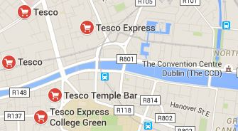
Features:
The 15 Euro plans gives you unlimited calls and texts and then gives you 15 Euro in credit for you to use to purchase a data plan good for 30 days

Public Transit
There are a number of Dublin Transit Apps, which include maps and other services.
Apple:. https://tinyurl.com/pmpgwv9
Android https://tinyurl.com/njq5q4p
Airport Bus
https://tinyurl.com/nfllrv7
Single Fare 6 Euros Return fare is 10 Euros

Airport: Terminal 1
Bus and Rail Information Desk, Arrivals Hall.
Vending machines located at the Airlink Bus Stop.
Terminal 2
*Single Fares payable to Airlink Bus Driver.
City Centre:
Dublin Bus, 59 Upper O’ Connell Street.
City Tours

Maps and City Walks and Tours of Dublin
Dublin Map works offline
Apple: https://tinyurl.com/q4zcd8w
Dublin Maps and Walks
Apple: https://tinyurl.com/pdzcypj
Android: https://tinyurl.com/praquz6

Issue One Writer Judith Hellerstein, Editor Glenn McKnight
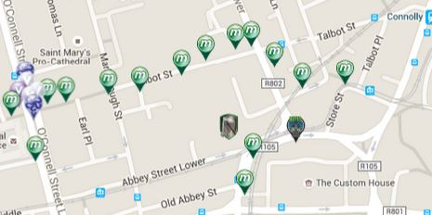Munzees
https://www.munzee.com/
Modern day digital scavenger Hunt

